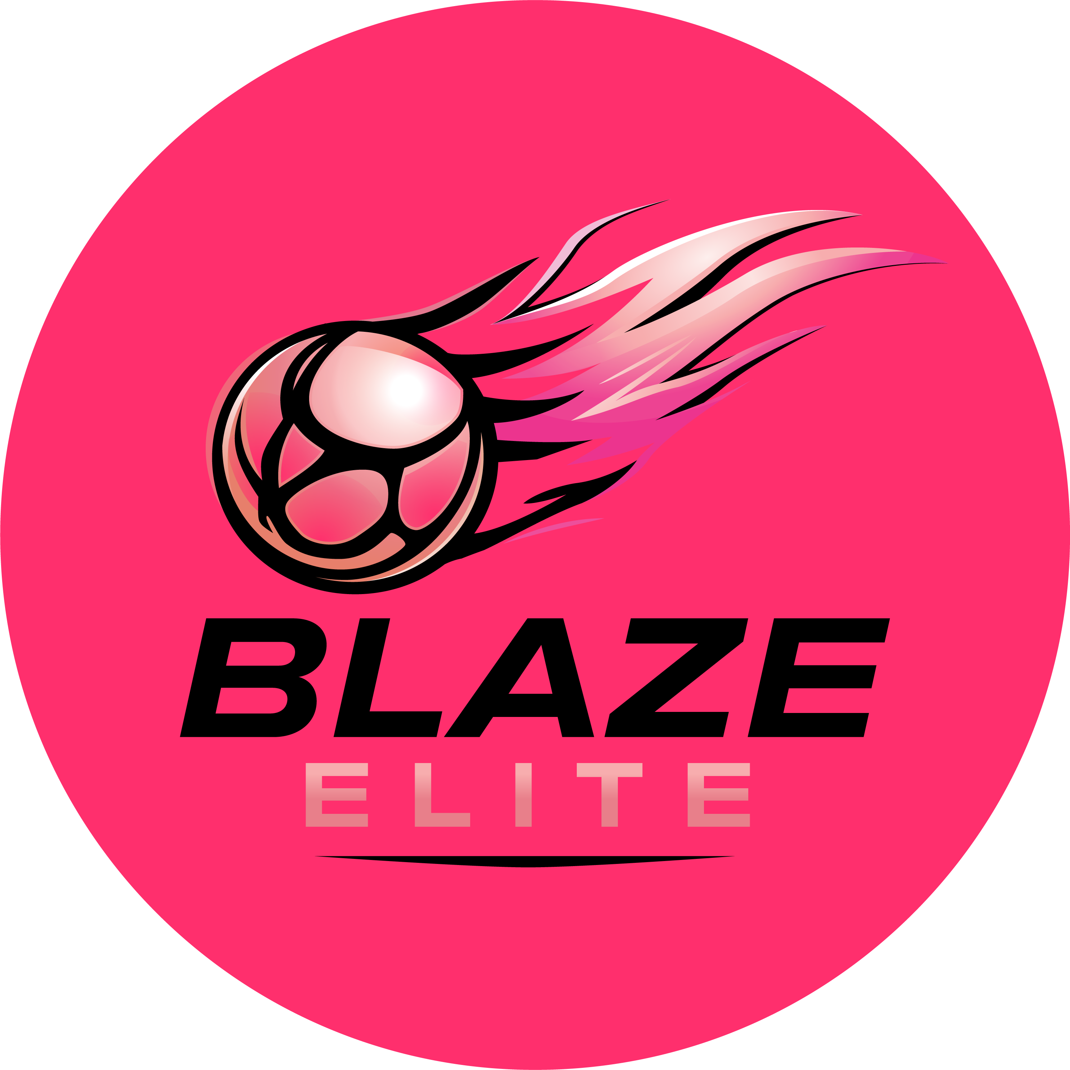

Coach & Volunteer Code of Conduct
Blaze Elite Netball Club

1. General Conduct
- Be a positive role model for netball, acting in a way that projects a positive image of Blaze Elite, and being fair, considerate and honest with athletes, parents/guardians and officials.
- Display high standards in language, manner, punctuality, preparation and presentation, so that time spent with you is a positive experience for everyone involved.
- Be mentally and physically fit to carry out your role.

2. Safeguarding Responsibilities
- Familiarise yourself with, and follow, the Safeguarding & Child Protection Policy at all times.
- Report any safeguarding concern to the Safeguarding & Welfare Officer promptly.
- Avoid being alone with a single athlete wherever possible; ensure another adult is present or visible.
- Hold a current DBS check, England Netball safeguarding certification and first aid qualification, kept up to date.

3. Coaching Standards
- Exercise reasonable care and skill in carrying out your duties, keeping your qualifications current and staying up to date with the latest coaching practice and development.
- Apply the rules of the game, and Blaze Elite's selection approach, consistently, independently and impartially.
- Seek to inspire and motivate each athlete in line with their own ability, to help them play to the best of their potential.
- Provide planned and structured training appropriate to athletes' abilities and goals, ensuring equal attention and opportunity for all, including modified plans for athletes managing sickness or injury.
- Where acting as a Lead Coach, support and mentor less experienced coaches, offering planned, structured and in-the-moment feedback to assist their development.
- Ensure the training and competition environment is safe and appropriate for the age, physical and emotional maturity, experience and ability of the athletes involved.
- Follow all health and safety regulations that apply to your role, and the requirements of the Health & Safety Policy.

4. Communication with Parents & Athletes
- Direct communication about selection or performance decisions to the athlete (and parent/guardian, where appropriate) rather than discussing it with other parents.
- Respond to parent/guardian queries raised through the agreed communication channels in a timely and respectful manner.

5. Social Media
Coaches and volunteers must not post negative, disparaging or inflammatory comments about Blaze Elite, its athletes, families, or fellow coaches and volunteers, on social media or any public platform.

